**CHECKPOINT_EVERY=500**

**DROPOUT_KEEP_PROB=2.5**

**EMBEDDING_DIM=128**

**EVALUATE_EVERY=100**

**FILTER_SIZES=3,4,5**

**L2_REG_LAMBDA=0.0**

**NUM_EPOCHS=200**

**NUM_FILTERS=128**

**Optimizers:** AdamOptimizer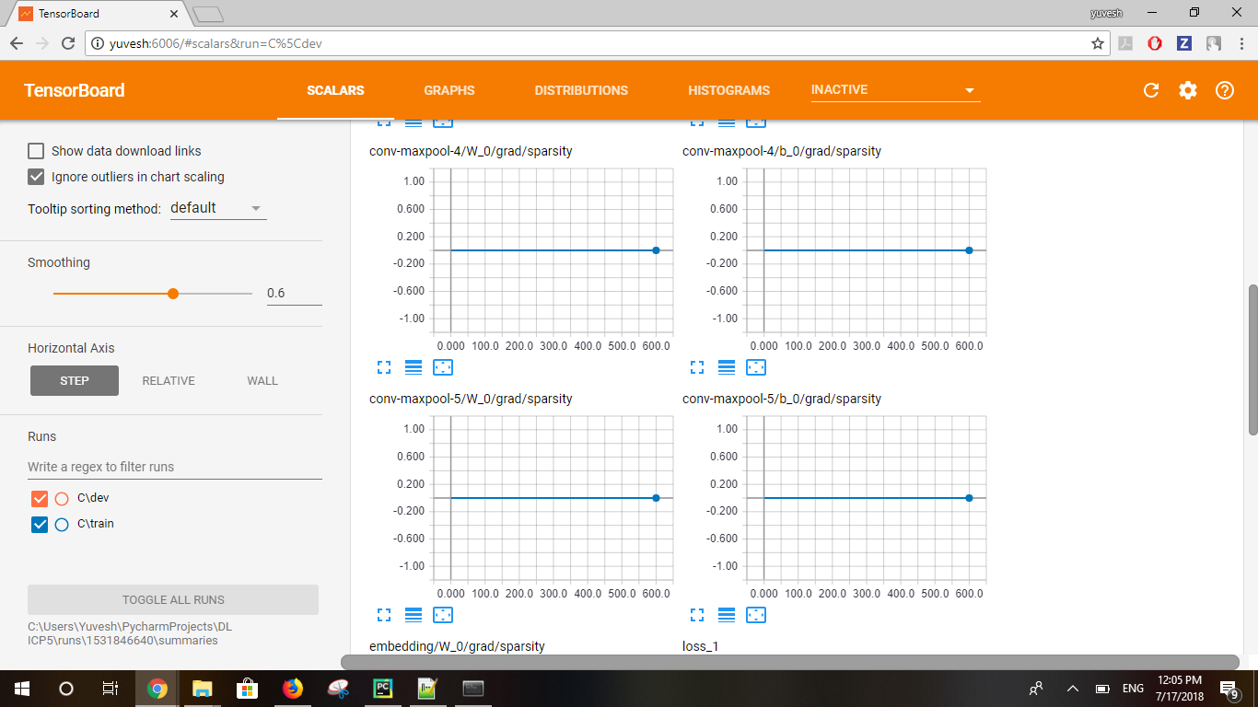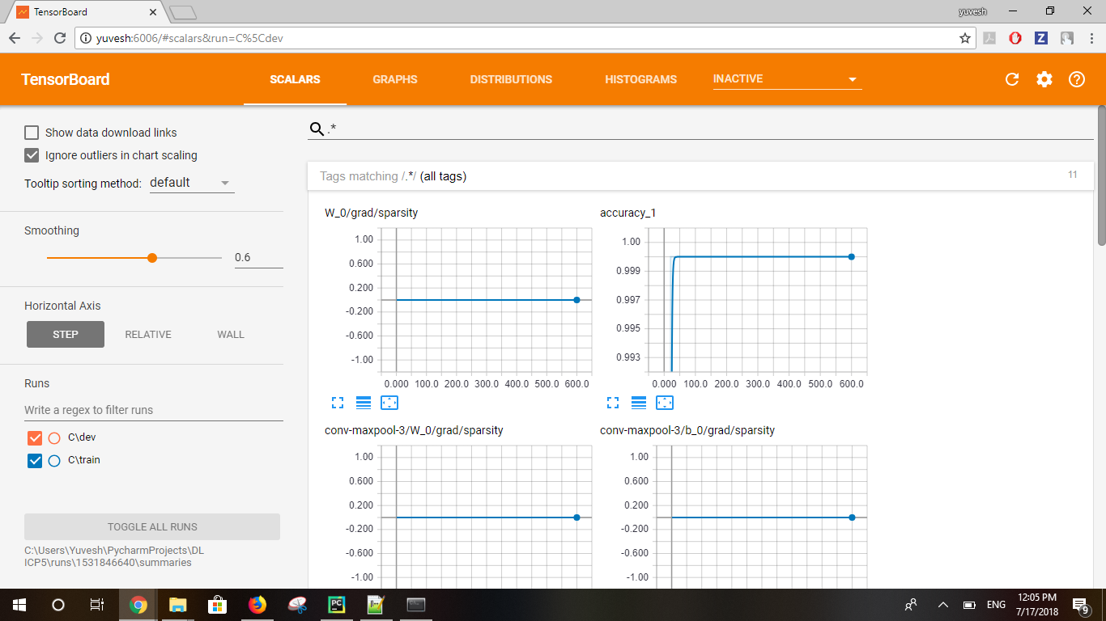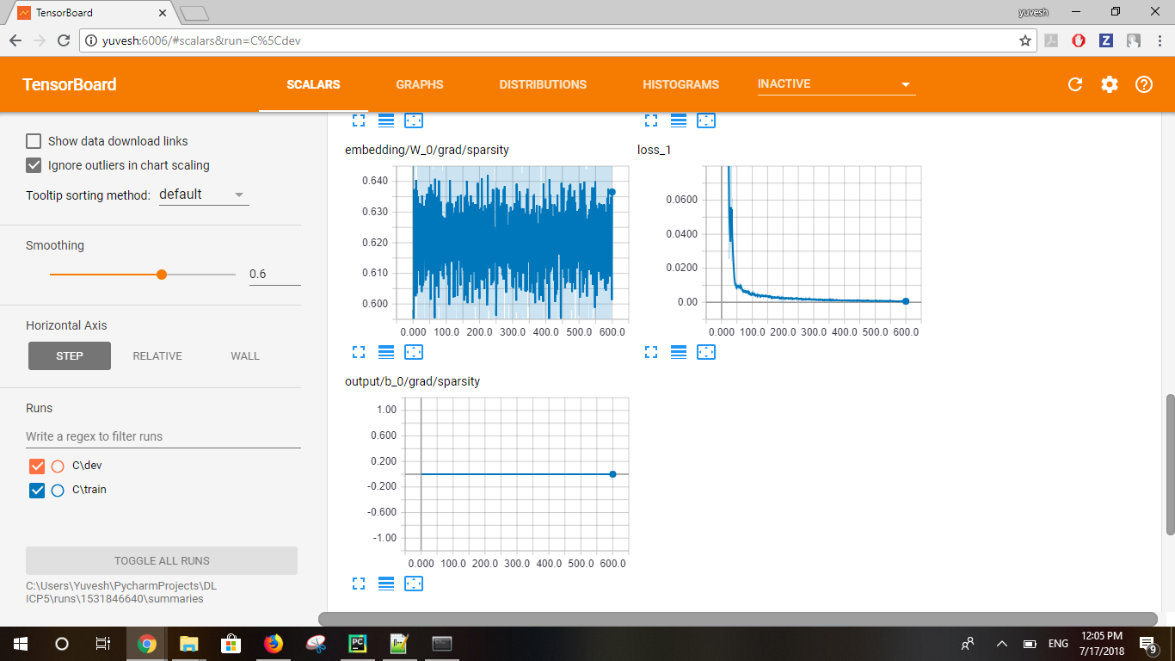

**CHECKPOINT_EVERY=500**

**DEV_SAMPLE_PERCENTAGE=0.1**

**DROPOUT_KEEP_PROB=2**

**EMBEDDING_DIM=128**

**EVALUATE_EVERY=200**

**FILTER_SIZES=3,4,5**

**L2_REG_LAMBDA=0.5**

**NUM_CHECKPOINTS=50**

**NUM_EPOCHS=150**

**NUM_FILTERS=256**

**Optimizers:** RMSPropOptimizer

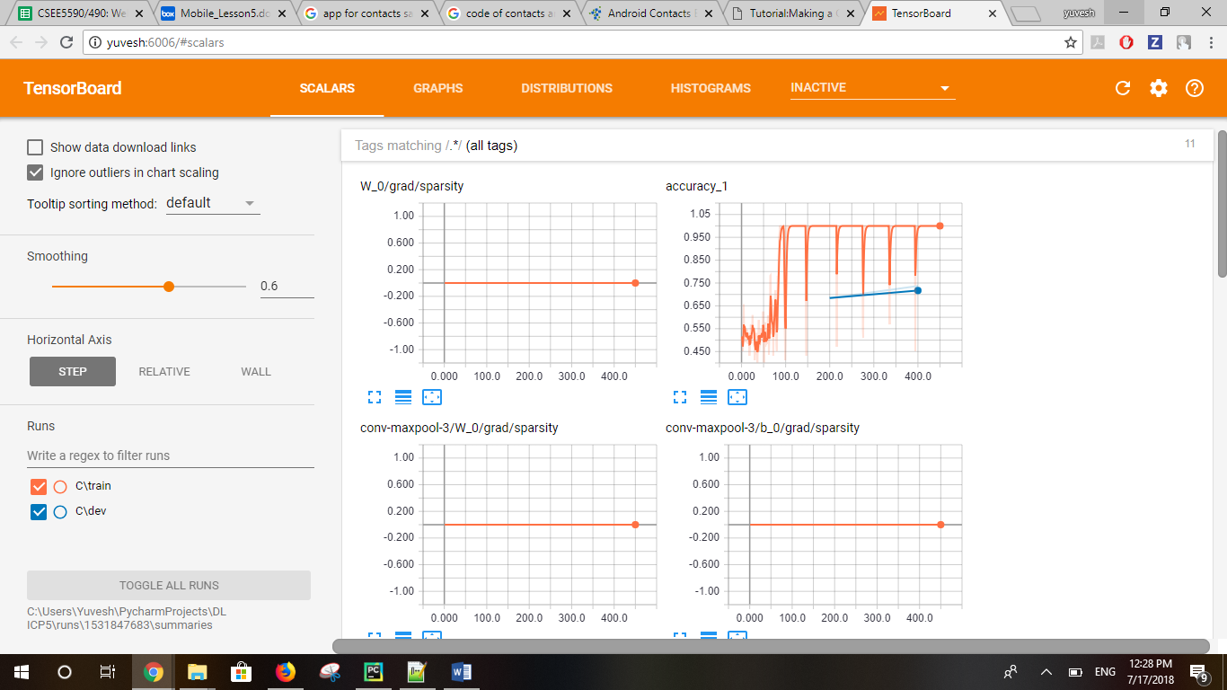

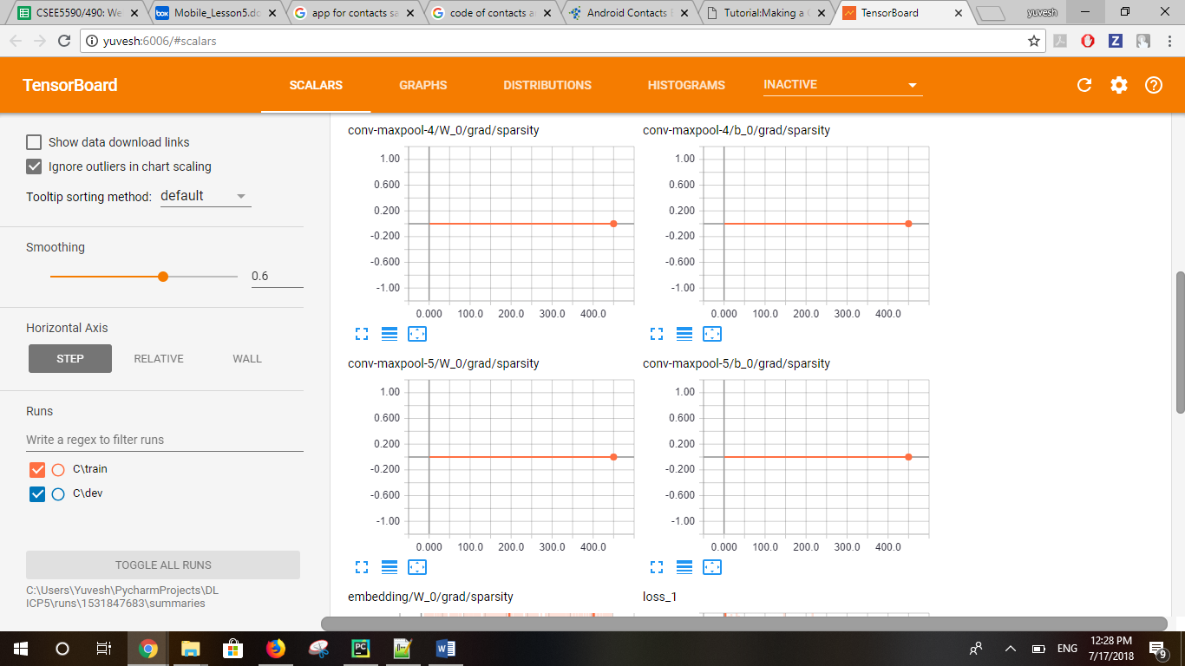

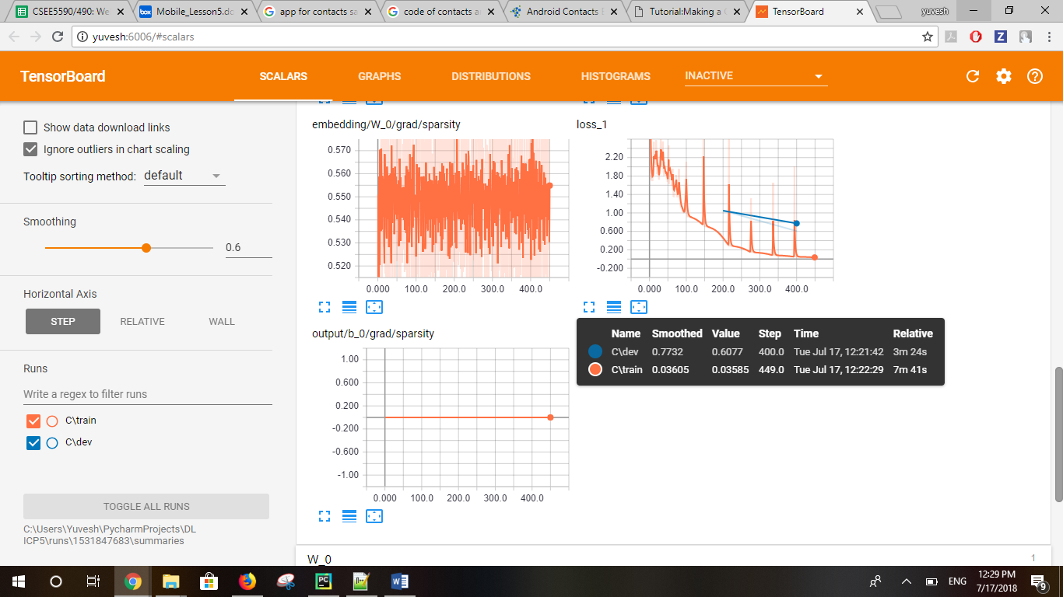

**Changing only optimizer**

**Optimizers:** ADamoptimizer

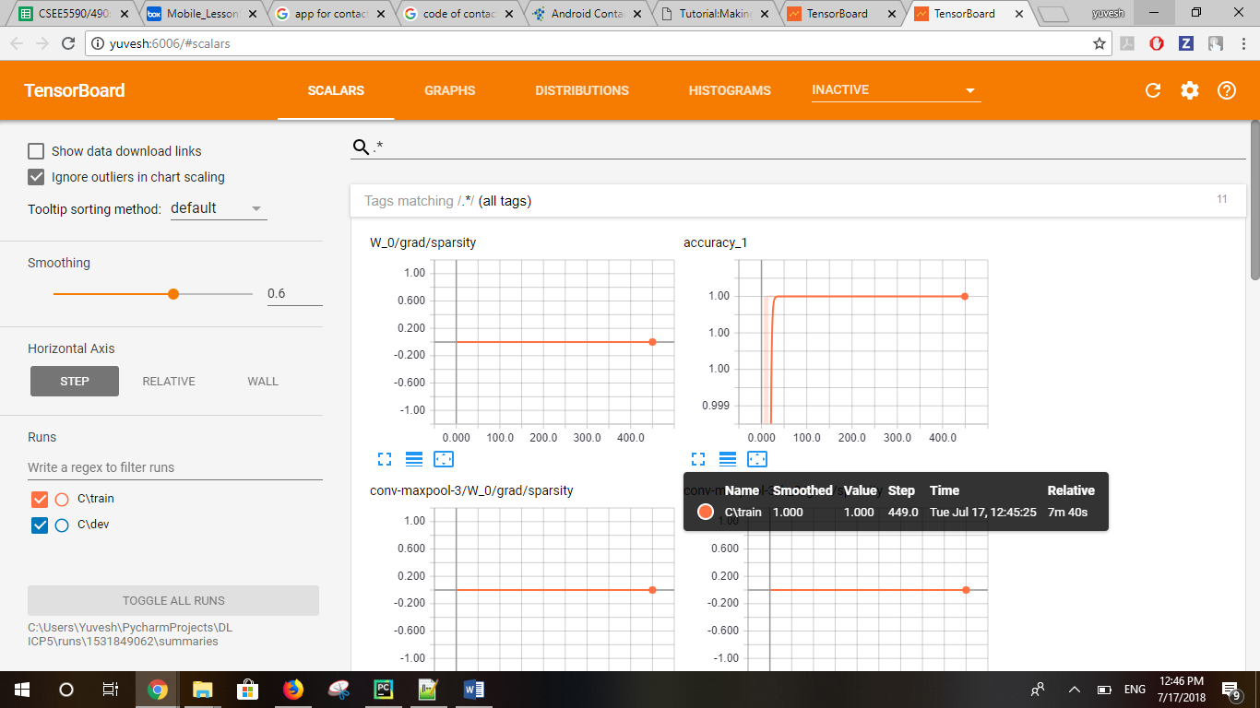

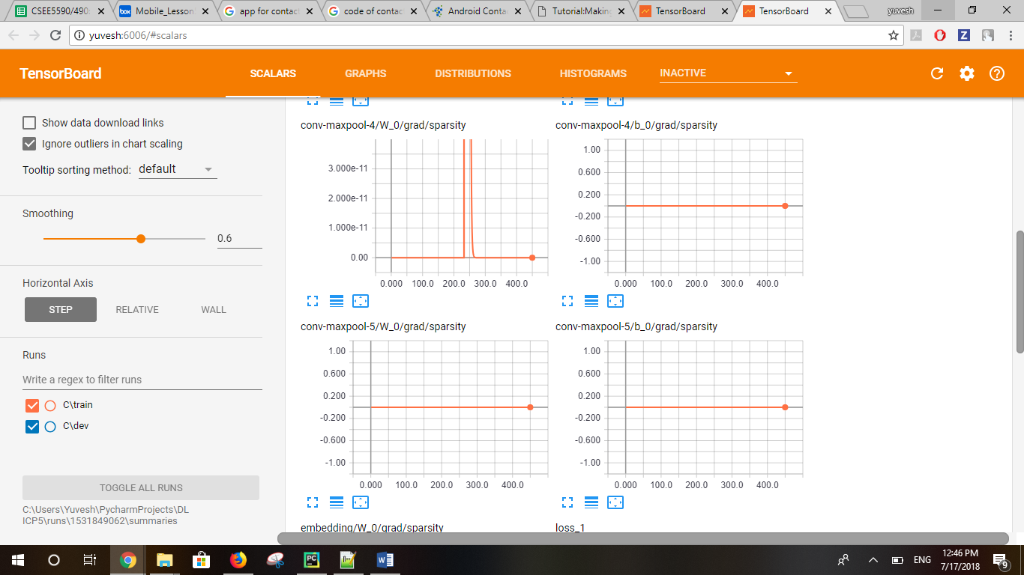

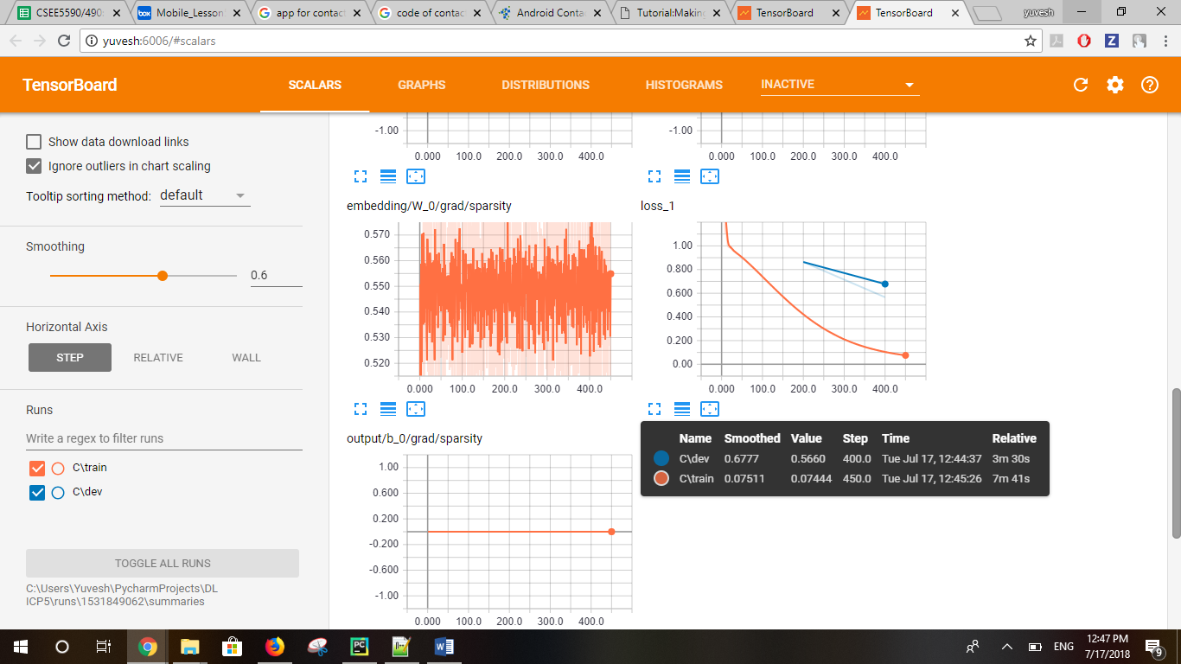

**Optimizers:** AdadeltaOptimizer

